This lab requires that you take a Hot Backup of your database.

The lab output that you send me does not have to be in APA format. You can send me the output from your labs in several ways, for example:
- Capture screen shots (print screen key) and put them in a Word document
- Cut and paste output from your screen into a Word document

I won’t be too picky about the output format, just as long as I can tell that you successfully completed each recipe.

The rest of this document describes how to take a Hot Backup of your database.

Taking a Hot Backup in Citrix:

Here is a procedure for taking a Hot Backup of your database datafiles in Citrix:

1. Create a folder named hotBackups
2. Determine the location of your datafiles
3. Ensure your database is in archivelog mode
4. SQL> alter database begin backup;
5. Copy the files identified in step one to the hotBackups folder
6. SQL> alter database end backup;

In a real production environment, this procedure can vary by quite a bit. This document just shows you one method for quickly taking a Hot Backup of your database datafiles.

In Citrix, this isn’t always straightforward like it is in most other environments. This is because there is a mismatch in what you see in the data dictionary versus how the drives are actually mapped.

Login to Citrx:
http://citrix.arn.regis.edu

You should see a screen like this:

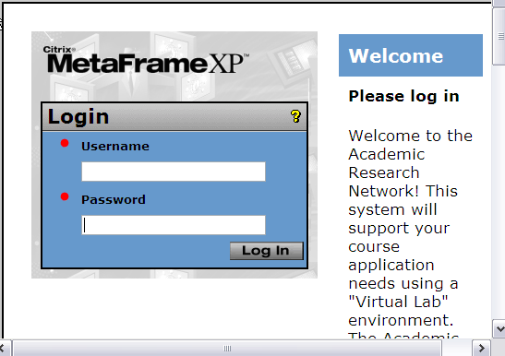

Login with your credentials. Next Click on “Oracle Desktop”

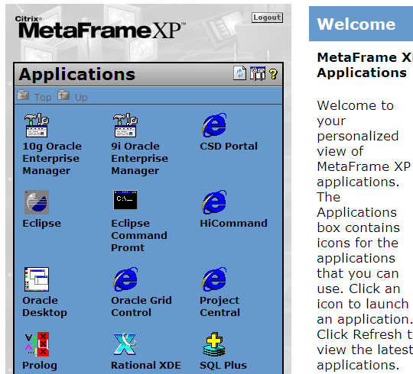

If you haven’t mapped your “Ora01” drive, then do so (see the cold backup document for steps).

Create a folder named hotBackups:

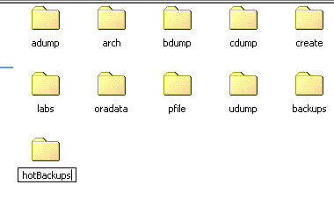

The “oradata” folder contains subfolders that contain your datafiles. Verify that your datafiles are in the folders Disk1 and Disk2 folders (this varies by term).

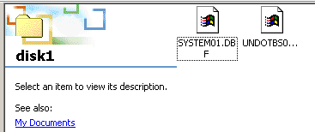

Alter your database into backup mode:

SQL> alter database begin backup;

Right click on Disk1 and copy its contents to the hotBackups folder. Do the same thing for the Disk2 folder.

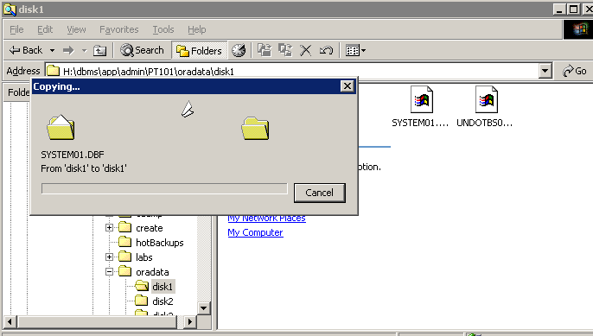

After the files are copied to the hotBackups folder, then alter your database out of backup mode.

SQL> alter database end backup;

